Voice for Global Bangladesh visits the 40th FIFA Fobana Convention Toronto 2026
Following an eight hour flight between London Heathrow and Toronto with a five hour time difference myself (Colin Short), VfGB President Dr Hasanat Husain MBE and his wife VfGB Executive Mrs. Shahida H. Husain FRSA arrived at the Toronto Don Valley Hotel, the initial
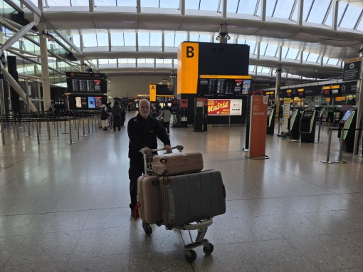
Outward bound at Heathrow on 1.9.26 to Toronto.

venue for the 40th FIFA Fobana Convention, where members of the Bangladeshi community and organizations from North America and Canada would meet to celebrate their culture. Our stay was made more enjoyable as many of the Fobana organizers and attendees stayed at the same hotel allowing us time to discuss the event and the recent changes in the governance of Bangladesh. The event was organised by Dr Abu Jubair Dara and supported by his committee of volunteers, many of whom we met on the evening of our arrival at the Bhojon Bari at Lobongo for what for us was a late meal ending around 2am uk time. The next few days prior to the start of the convention we visited a number of the Husain’s relatives, Unionville, plus multiple visits to Tim Hortons.
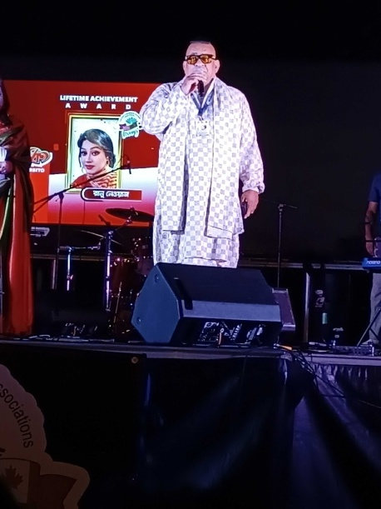
Dr. Abu Jubair Dara, Convenor of the 40th Federation of Banagladeshis of Northern America (FOBANA) event, 4-6 September 2026.

The Friday evening was the start of the festivities at the Don Valley venue with awards and entertainment by many Bangladeshi celebrities including singers and dancers.
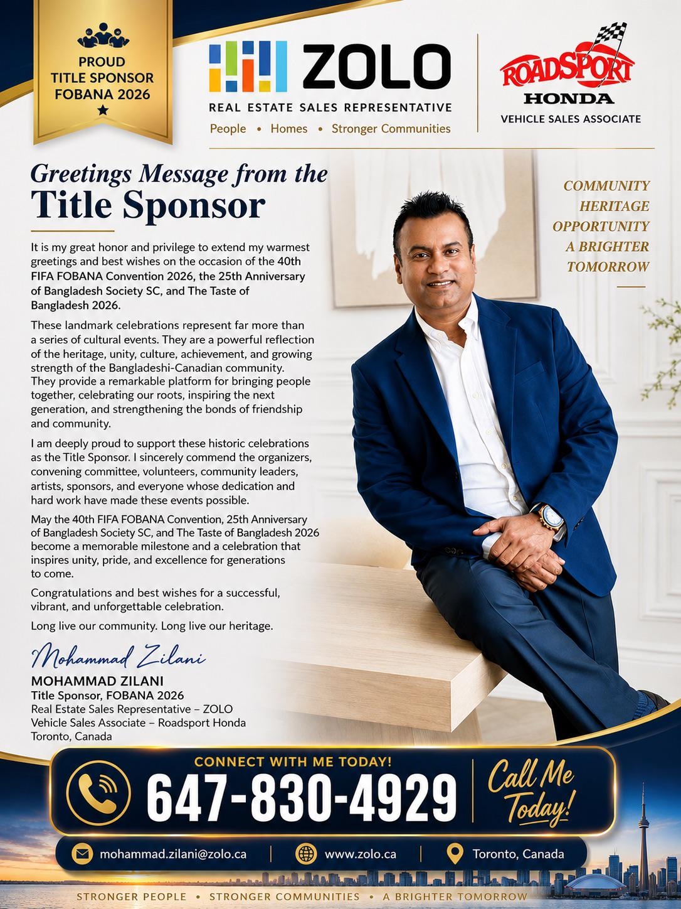 | 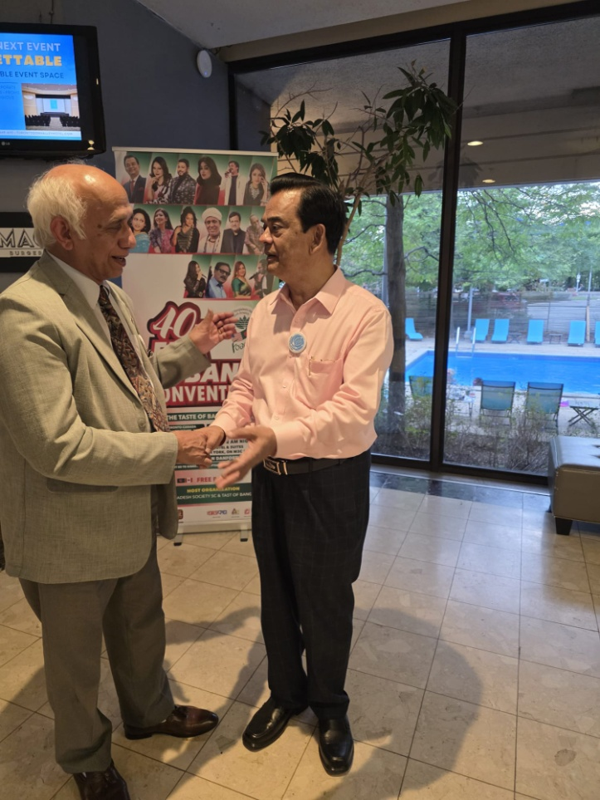
 | With the famous magician Juel Aich
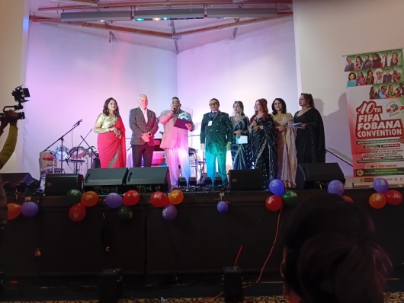 | 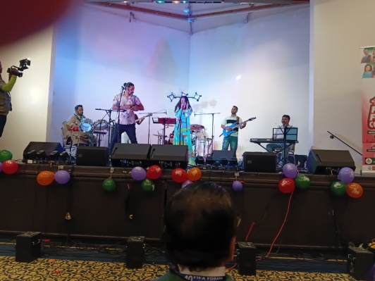
Friday night at Don Valley | Don Valley
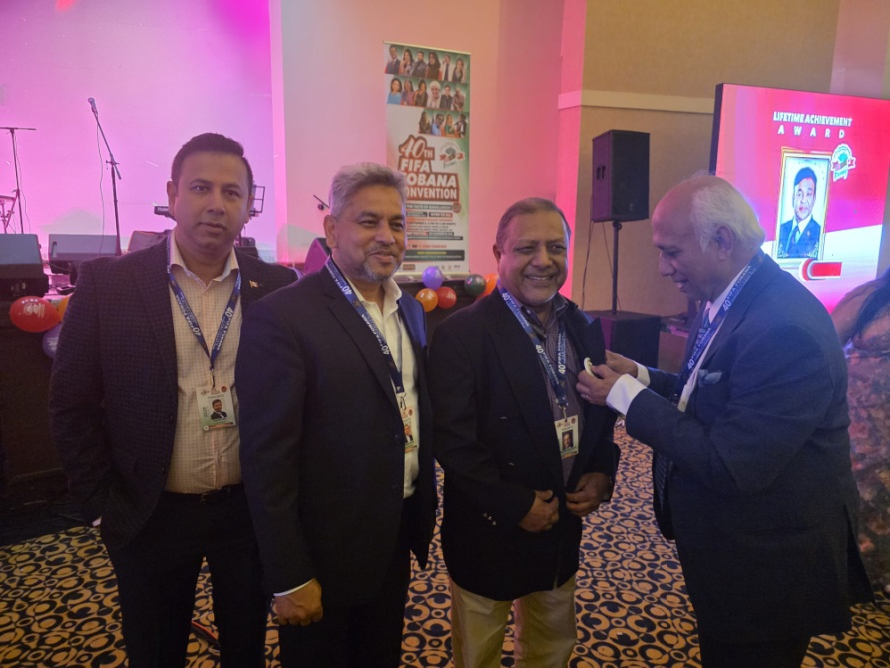 | 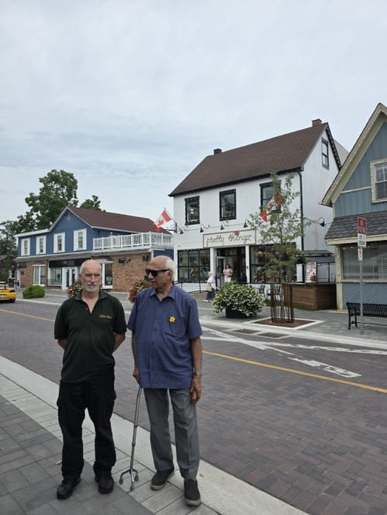
Putting the VfGB badge on VfGB Toronto Executive Mr. Shahed Khondoker Tuku on 4.9.26 | Unionville

The event closed in the early hours of Saturday morning. The following evening the event reopened at a second venue where we were given front row seats and an entire street was closed off by the authorities with a stage erected for more awards and performers. In addition hundreds of seats were laid out for anyone who attended and 100 stalls set up selling traditional food for the attendees that exceeded an estimate 60,000 people most of whom stood and watched the event.
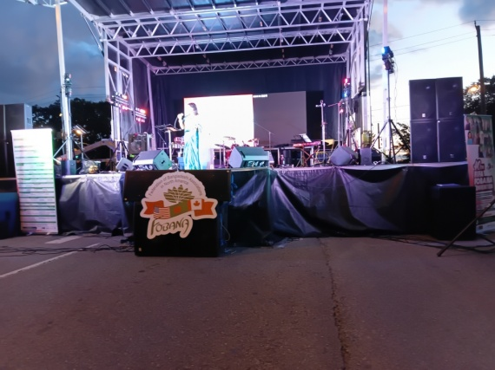 | 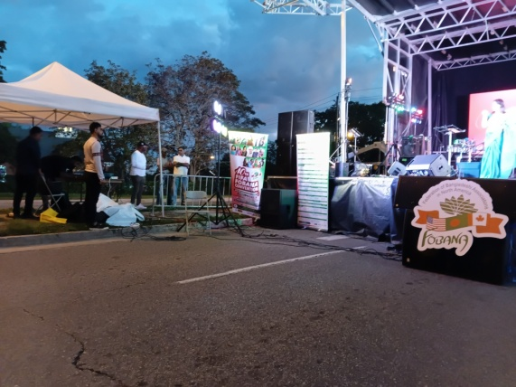
Open air stage on | Saturday and Sunday evening
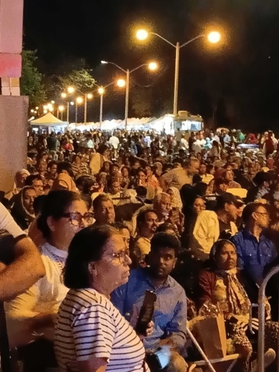 | 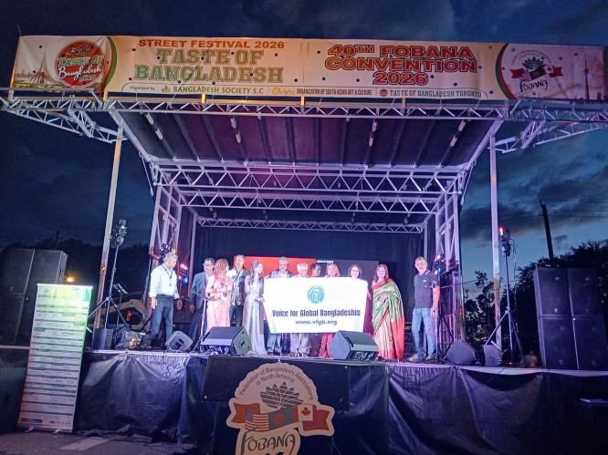
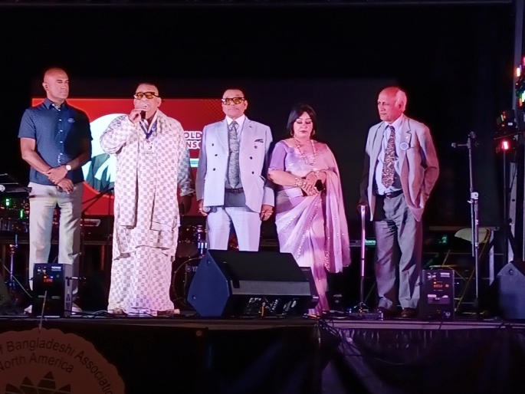 | 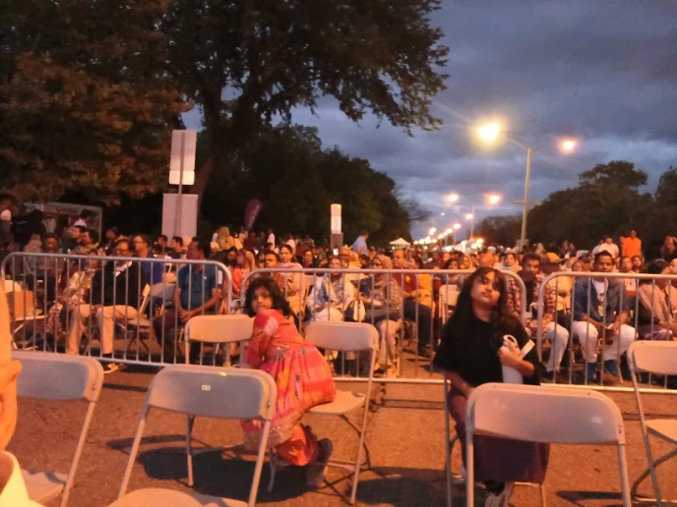

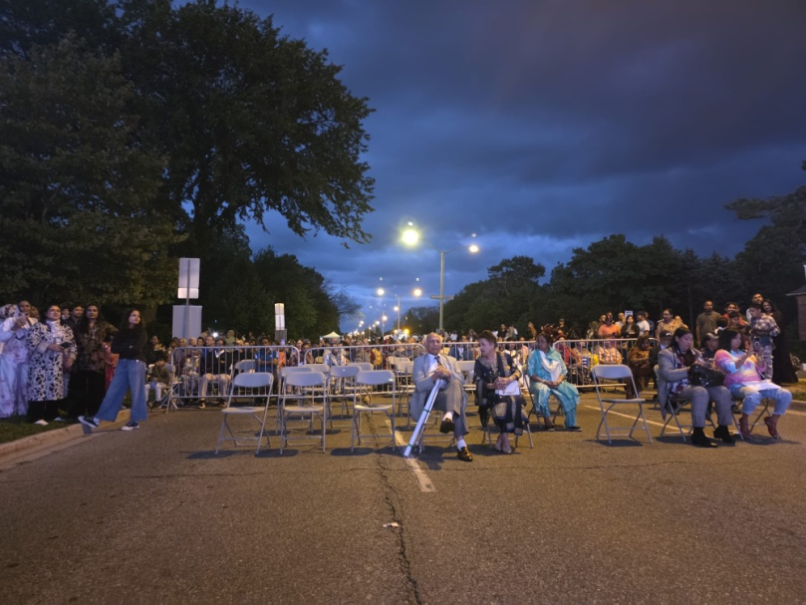 | 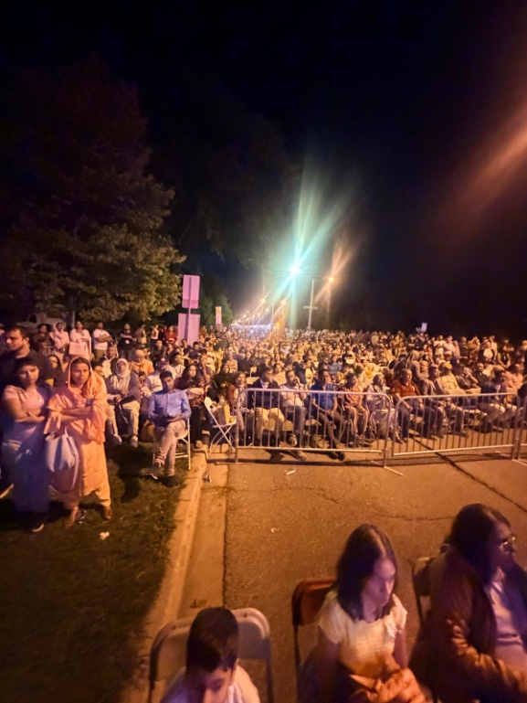
Start of the open air show on 5.9.26 | View of the crowd from the stage
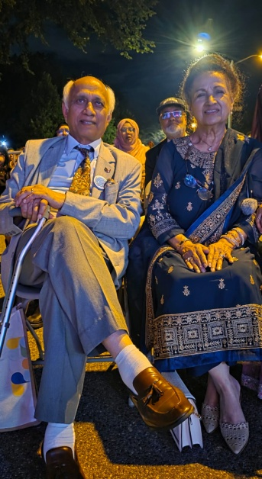 | 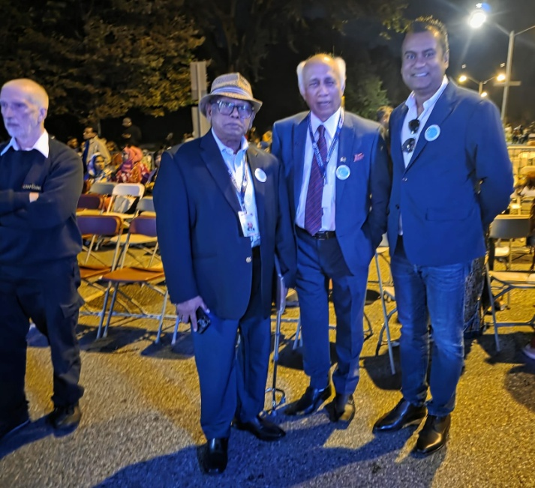
Dr and Shahida Husain | Me, Dr Husain and Fobana Executives

The event was due to finish at 11pm, however the inimitable Dr Dara took advantage of the local councilor (pictured above in the blue shirt) after he addressed the audience by asking him to extend the licence for another 30 minutes. A decision that was greeted with enthusiasm by the audience and probably earned him some additional votes in the forthcoming elections.
Saturday saw the final night of the event, again located at the street party, unfortunately our attendance was delayed and we missed the awards ceremony where Dr Husain was awarded a lifetime achievement award. The evening continued with more performers and the last act resulted in the audience joining with the singer and some of them dancing in front of the stage. The performers and co-ordinators retired to Dr Dara’s suite at the Don Valley where a celebratory meal was laid out for them. The whole event was a great success due entirely to those involved in it’s organization and generated strong bonds between the Bangladesh Society of Canada, Voice for Global Bangladesh and Voice For Justice.
Following a well earned rest two of the executives of the Bangladesh Society of Canada (BSC) Mr. Sheikh Muttalib and Mr. Sohel Khayer took us for an afternoons fishing at Port Hope for salmon and Lake Rice for Sun fish.
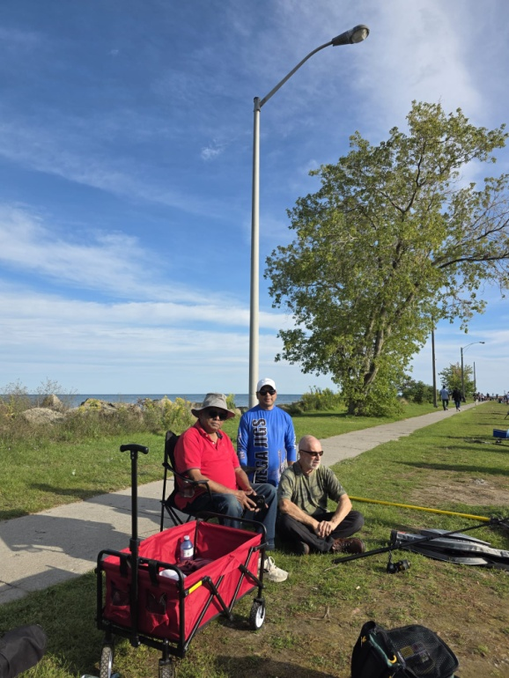 | 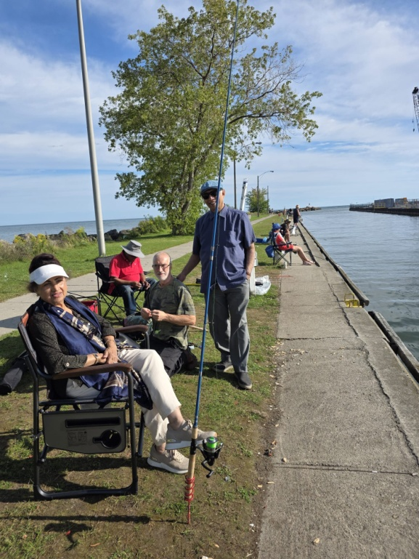
Port Hope | Port Hope
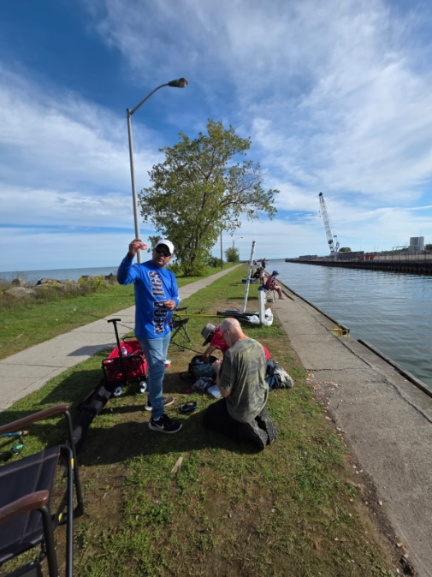 | 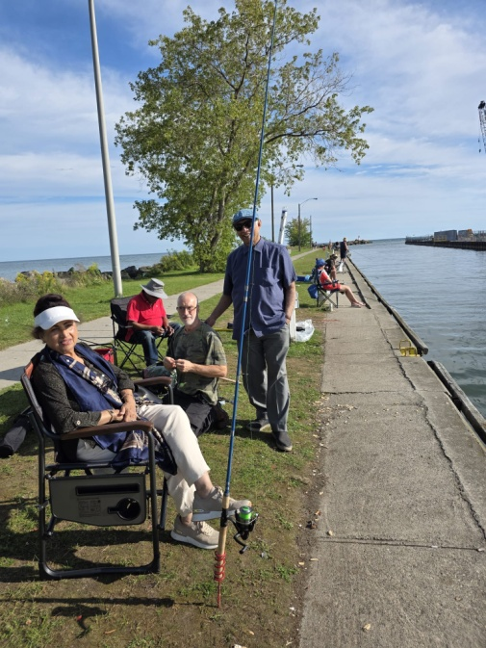
Fishing at | Port Hope
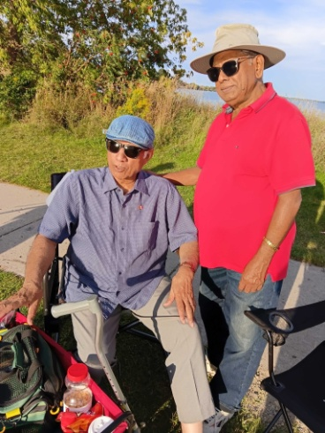 | 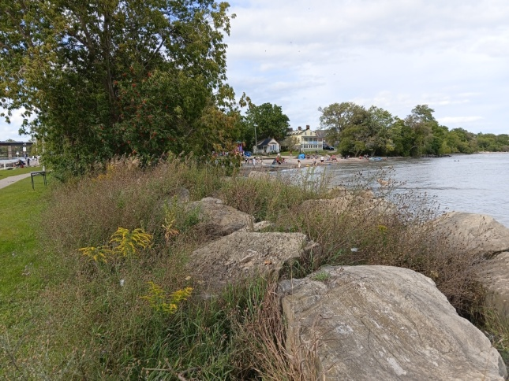
Port Hope | Lake Ontario
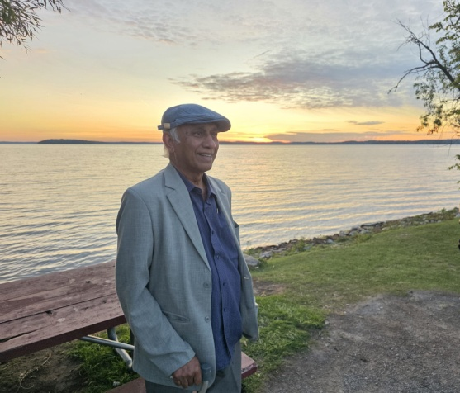 | 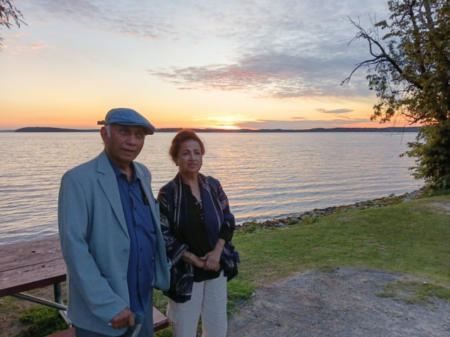
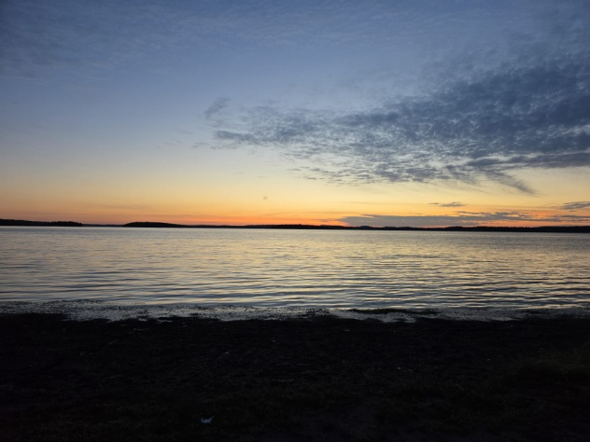 | 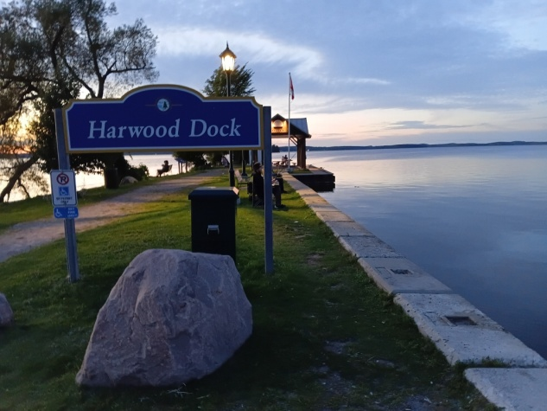
Sunset at | Rice Lake

The next day was a rest day for us before be boarded our flight back to London. I was struck by the vastness of Canada especially lake Ontario that looked more like an ocean, the fabulous road and public transport network, but mostly the food and fuel prices that were almost 50% of those in the UK. Finally I must thank Dr. Abu Jubair Dara whom I first met in February at his home in Dhaka, when myself and Dr Husain visited Bangladesh as representatives of Voice for Global Bangladesh to act as International observers for the national elections, for his generosity inviting us to this fantastic event that will remain a memory I will treasure.

